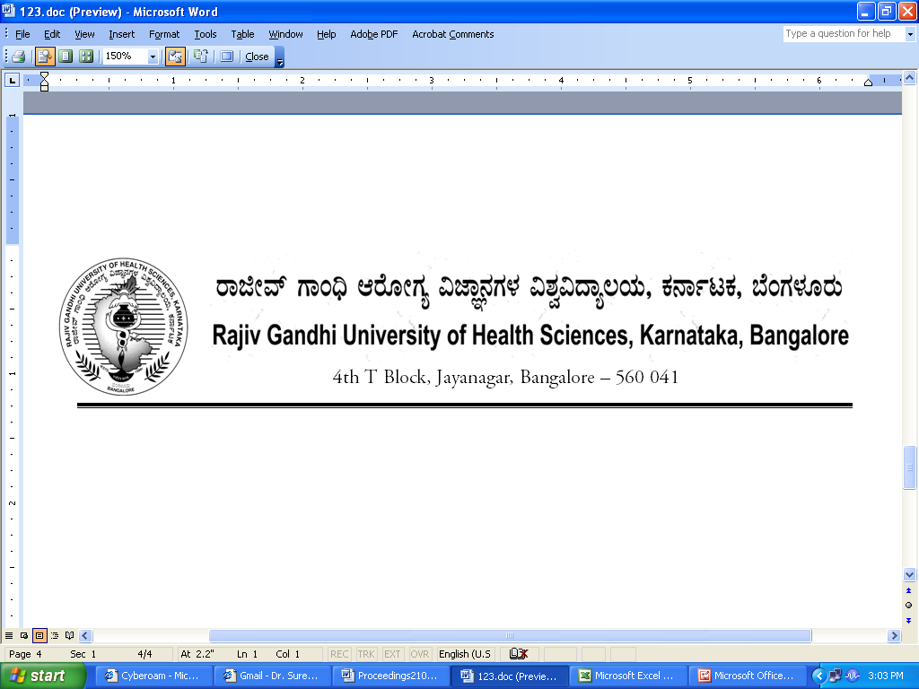
Reg(E)Exam/UG-AHS/February - 2018 Date: 29/01/2018

To,

The Director / Dean / Principals of
Allied Health Sciences Colleges
Affiliated to RGUHS.

Sir / Madam,

Sub : | Providing the number of students appearing for UG Allied Health Sciences course examination February- 2018.

With reference to the above, you are hereby requested to send the number of students appearing February-2018 UG Allied Health Sciences courses examination same may be informed in the following proforma on or before 15/02/2018 through fax: 080-26961941 or email:drexamrguhs@gmail.com without fail to speed up the examination process.

Name of the Student | Register No | Name of the Course

Thanking you,

Yours faithfully,

Sd/-
Registrar [Evaluation]

